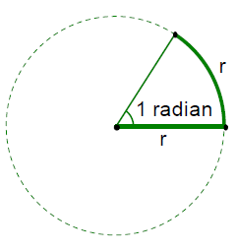Module 3 Lesson 3

**Radian Measure** and

**Arc Length**

Learning Targets…

I can define radian measure and draw one radian in standard position on the unit circle.

I can use the relationships between the radius of a sector of a circle and the sector’s angle, along with its intercepted arc to solve problems. $s=θr$

I understand that an angle with full circle rotation measures 2π radians and an angle with a semicircle rotation measures π radians. These facts aide in converting between radian and degree measure.

**Converting from degrees to radians**

$$Degrees°∙\frac{π}{180°}= radians$$

Convert the following angles into radian measure. Write the answer in terms of π and to the nearest tenth.

120o 45o -270o  345o

**Converting from radians to degrees**

$$radians∙\frac{180°}{π}=Degrees°$$

Convert the following angles into degree measure.

$\frac{π}{6}$ $\frac{2π}{3}$ $1.92 radians$ $\frac{-π}{12}$

Another way to quickly think of radians is that = 180o so just substitute 180 in for $π$ when converting radians to degrees.

For example, $\frac{π}{2}=\frac{180°}{2}=90°$

Find

$\frac{π}{4}$ $\frac{π}{10}$ $\frac{4π}{3}$

**Finding the Cosine, Sine and Tangent of a Radian Measure.**

Find the exact value of each of the following:

1. $\sin{\frac{π}{4}}$ 4. $\tan{\frac{5π}{4}}$
2. $\cos{\frac{-4π}{3}}$ 5. $\sin{\frac{-5π}{6}}$

3. $\sin{\frac{3π}{2}}$

**Central Angles and Lengths of Intercepted Arcs**

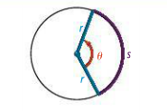For a sector of a circle with radius $r$ and a central angle of measure $θ$ (***in radians***), the length s of the intercepted arc is

$s=θr$.

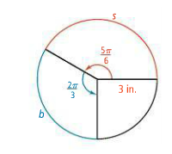Find the lengths s and b in the given diagram, rounding to the nearest tenth.

Find the arc length if the central angle of the sector is $225°$ and the radius is 4 in.

Find the central angle of a sector of a circle if the arc length is 6 feet and the radius is 2.5 feet.

Applications

1. A dog is attached to a $10 foot$ leash. He travels around an arc that has a length of $25 feet$. Which of the following represents the radian angle he has rotated through?

(1) (3)

(2) (4)

2. A wheel whose diameter is $3 feet$ rolls a distance of $45 feet$ without slipping. Through what radian angle did the wheel rotate?

(1) (3)

(2) (4)

3. The distance from the center of a Ferris wheel to a person who is riding is $38 feet$. What distance does a person travel if the Ferris wheel rotates through an angle of ?

(1) (3)

(2) (4)

4. A golfer swings a club about a pivot point. If the head of the club travels a distance of $26 feet$ and rotates through an angle of $5 radians$, which of the following gives the distance the club head is from the pivot

point?

(1) $1.7 feet$ (3) $5.2 feet$

(2) $2.6 feet$ (4) $7.2 feet$